**Anomaly Detection On Low Resolution Photography On The Martian Surface Using High Dimensional Tensor Decomposition**

Practicum Final Report

Anthony Chan

July, 2024

# Executive Summary

This study uses high dimensional tensor decomposition such as Tucker decomposition and CP(PARAFAC) decomposition to reduce the dimension of sequence of images into signals to train anomaly detection models to detect novel or anomalous objects on new image datasets. This study shows that Tucker decomposition with autoencoder achieved the highest performance with accuracy of 58% identified anomalies. Other anomaly detection techniques under Tucker's decomposition were performed such as one-class SVM, random forest, and ensemble of autoencoder and one-class SVM. CP decomposition was performed with one-class SVM, autoencoders, random forests and ensembled autoencoder with one-class SVM.

## Key Findings

* Tucker decomposition with autoencoder is the best performing model for this study. It is 2% more accurate than the second-best method- Tucker with one-class SVM. This was achieved using the decomposition rank of (95, 65, 65).

## Main Recommendations

* Performing Tucker decomposition on image sets to reduce them into 2-dimensional signals prior to anomaly detection is a performance effective way to detect anomalies.
* Use of autoencoders with decomposed signals from Tucker decomposition is an effective machine learning method for detecting anomalies on images.

# Introduction

## Background

The detection of novel or anomalous objects in images is a crucial task in many domains, including space exploration. Accurate anomaly detection can provide significant insights and facilitate critical decision-making processes. This project focuses on exploring novel method in anomaly detection by evaluating the effectiveness of two decomposition methods, CP (CANDECOMP/PARAFAC) and Tucker decomposition, in conjunction with machine learning models. Specifically, One-Class Support Vector Machines (OC-SVM), autoencoders, random forest, and their combination in detecting anomalies.

The image dataset used in this study comes from a previous research conducted by Kerner et al., featuring images captured by NASA's Mars Science Laboratory (MSL) Curiosity rover. This dataset provides a set of images, ideal for evaluating the proposed methods. Due to computational constraints, a subset of the original dataset was used, consisting of 200 images for training and 50 images for testing, to ensure reasonable convergence on a mid-performance laptop.

While this study utilizes low-resolution Martian photography, the methodologies and findings are not exclusive to this type of data. The approaches developed and tested in this project can be generalized and applied to other image sets in various domains, such as medical imaging, industrial inspection, and environmental monitoring, making the results widely applicable beyond the context of space exploration.

## Objectives

Evaluate Decomposition Methods: To compare the effectiveness of CP and Tucker decomposition techniques in reducing the dimensionality of image sets while retaining essential features for anomaly detection.

Assess Anomaly Detection Models: To analyze the performance of different anomaly detection models, including OC-SVM, autoencoders, random forests, and an ensembled model combining OC-SVM and autoencoder, when trained on decomposed image signals.

Determine Optimal Dimensions: To determine the optimal dimensionality or rank for each decomposition method that maximizes anomaly detection performance.

Performance Metrics Analysis: To evaluate the performance of these models using metrics such as accuracy to identify the best combination of decomposition method and anomaly detection model.

# Methodology

## Data Collection

The image dataset used in this study was sourced from a prior research conducted by Kerner et al., which is hosted online. This dataset comprises images taken by NASA's Mars Science Laboratory (MSL) Curiosity rover. The original dataset is extensive, featuring a variety of images capturing different aspects of the Martian surface. The original dataset is 1.7 GB in size. For the purpose of this study, a subset of the original dataset was used to ensure that the experiments could be conducted efficiently on a mid-performance laptop. This subset characteristics is as follows:

80-20 split for training and testing datasets:

|  |  |  |  |
| --- | --- | --- | --- |
| **Dataset type** | **# of image sets** | **# of non-anomaly images** | **# of anomaly images** |
| Training | 200 | 200 | 0 |
| Test | 50 | 20 | 30 |

Table 1. Training and Test Datasets

Each image set consists of 6 near similar images taken consecutively on the same object by the MSL camera, and each image is 64 x 64 resolution. The selected subset is randomly sampled from the original dataset and therefore provides a representative sample of the original dataset while allowing for reasonable convergence times during model training and testing.

The following images are three examples of non-anomalous images sets:

Figure 1. Non-anomalous image sets

The following images are three examples of anomalous image sets:

Figure 2. Anomalous image sets

Image decomposition transforms multiple images into a low dimension representation. In this case, a 2-dimensional signals, which is followed by running through machine learning models to detect anomalies.

Averaging the rows of this 2-dimensional representation, we can plot them as signals of a single function. The following shows plotted signals for the first 10 non-anomalous image sets.

Figure 3. Non-anomalous image sets decomposed to signals

# Experiments

The experiments are divided into two categories. The first involves decomposing image sets using CP decomposition, and the second involves decomposing image sets using Tucker's decomposition. After decomposition, the data is flattened into a 2-dimensional array. This decomposed data is then used for training models, including one-class SVM, neural network autoencoder, random forest, and an ensemble method using both autoencoder and one-class SVM. After training, the test set is decomposed into 2-dimensional signals, and predictions are made using the trained models. For each machine learning method, a dimensionality or rank search is conducted to determine the decomposition rank that achieves the highest accuracy.

The optimal rank for CP decomposition is found after testing each rank from 5 to 100, with increments of 5 for the highest accuracy.

The optimal rank for Tucker’s decomposition is found after testing each combination rank of 3-tuple values from (5,5,5) to (95,95,95) with increments of 5 for the highest accuracy. Eg. (5,5,5), (5,5,10),…,(95,95,90),(95,95,95).

The following discusses each method and presents its results.

## CP decomposition with one-class SVM

The model used for this experiment is from the python sklearn.svm library. 5-fold cross validation grid search is performed to determine the best combination of the parameters for One-Class SVM. The parameter search performed are for the following parameters:

|  |  |  |
| --- | --- | --- |
| **Parameter** | **Value** | **Description** |
| Nu | 0.1, 0.5, 0.9 | Fraction for upper bound of training errors. |
| Gamma | Scale, auto | Kernel coefficient |
| Kernel | Rbf, poly, sigmoid | Kernel to be used by the model. |

**Results:**

44% accuracy achieved for predicting the test image sets. The optimal parameters found during training are nu: 0.1, gamma: scale, kernel: rbf. The optimal CP decomposition rank is 80. The following shows the confusion matrix.

Figure 4. CP with one-class SVM confusion matrix

## CP decomposition with Autoencoder

The autoencoder neural network consists of an input layer with 5120 neurons and an output layer also with 5120 neurons. This experiment uses the tensorflow.keras python library. The prediction from this autoencoder model returns a probability of an image set being an anomaly. The threshold set to consider an image set as an anomaly is 0.5. This was found after performing 5-fold cross validation from a range of threshold values from 0.1 to 0.9.

**Results:**

Accuracy achieved at 46% correctly predicted anomalies with CP decomposition rank of 85. The following is the confusion matrix.

Figure 5. CP with autoencoder confusion matrix

## CP with random forest

Random forest is performed using the IsolationForest library under the sklearn.ensemble python package. Parameters for this class are chosen through 5-fold cross validation.

|  |  |  |
| --- | --- | --- |
| **Parameter** | **Value** | **Description** |
| n_estimators | 50, 100, 200 | Number of base estimators. |
| Max_samples | Auto, 0.5, 0.75, 1.0 | Number of samples to train each base estimator. |
| Contamination | 0.05, 0.1, 0.2 | Proportion of outliers in the dataset. |
| Max_features | 0.5, 0.75, 1.0 | Number of features to use. |

**Results:**

38 percent accuracy achieved using the parameters 'contamination': 0.05, 'max_features': 0.5, 'max_samples': 'auto', 'n_estimators': 200 and with CP decomposition rank of 10.

Figure 6. CP with random forest confusion matrix

## CP with ensembled autoencoder and one-class SVM

This ensembled model experiments is performed by combining the autoencoder method and one-class SVM. The output from autoencoder is entered as input for one-class SVM. The same 5-fold cross validation is done as the standalone one-class SVM and the same number of neurons are used for the autoencoder.

**Results:**

This method achieved an accuracy of 56% using decomposition rank 35, which is higher than the rest of CP decomposition methods. Combining two detection models improves the accuracy of anomaly detection. The following shows the confusion matrix.

Figure 7. CP with autoencoder and one-class SVM confusion matrix

## Tucker with one-class SVM

Similar to one-class SVM with CP decomposition, a grid search 5-fold cross validation is performed during training for the following parameters:

|  |  |  |
| --- | --- | --- |
| **Parameter** | **Value** | **Description** |
| Nu | 0.1, 0.5, 0.9 | Fraction for upper bound of training errors. |
| Gamma | Scale, auto | Kernel coefficient |
| Kernel | Rbf, poly, sigmoid | Kernel to be used by the model. |

**Results:**

This method results in 56% prediction accuracy using decomposition rank (65,35,65). The following is the confusion matrix.

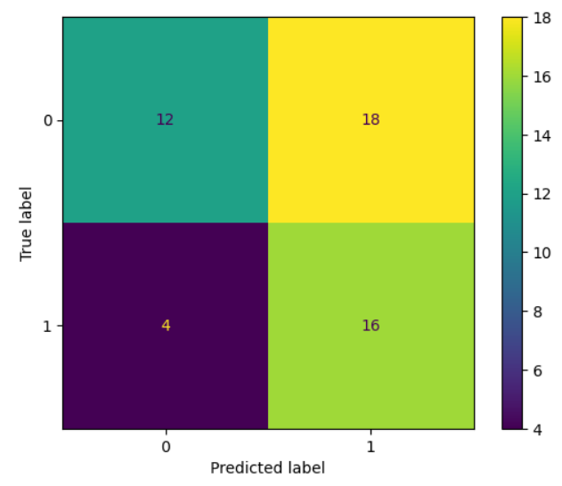

Figure 8. Tucker with one-class SVM.

## Tucker with Autoencoder Neural Networks.

Similar setup as with CP decomposition.

**Results:**

This method achieves 58% accuracy using decomposition rank (95, 65, 65), the most accurate among all models used. The following shows the confusion matrix.

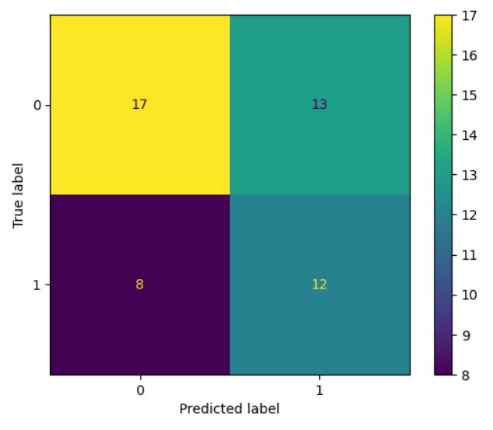

Figure 9. Tucker with Autoencoder neural network

## Tucker with Random Forest

Similar setup as with CP decomposition presented above.

**Results:**

This method achieves 46% accuracy with decomposition rank (5,65,5). The following shows the confusion matrix.

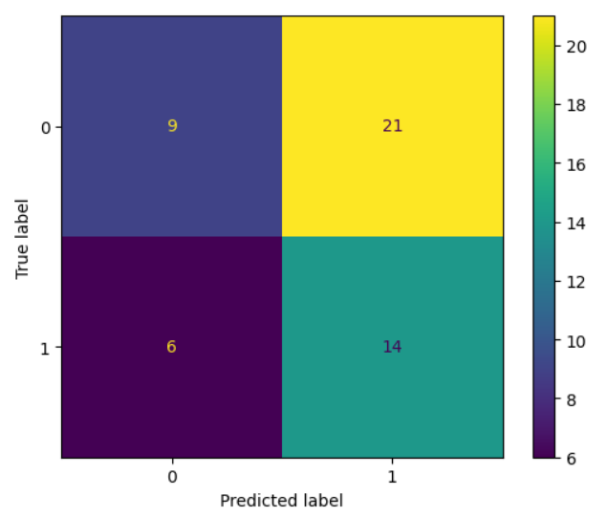

Figure 10. Tucker with Random Forest

# Tucker with ensembled autoencoder and one-class SVM

Similar setup as with CP decomposition presented above.

**Results:**

This method achieves 48% accuracy with decomposition rank (65,35,5). The following shows the confusion matrix.

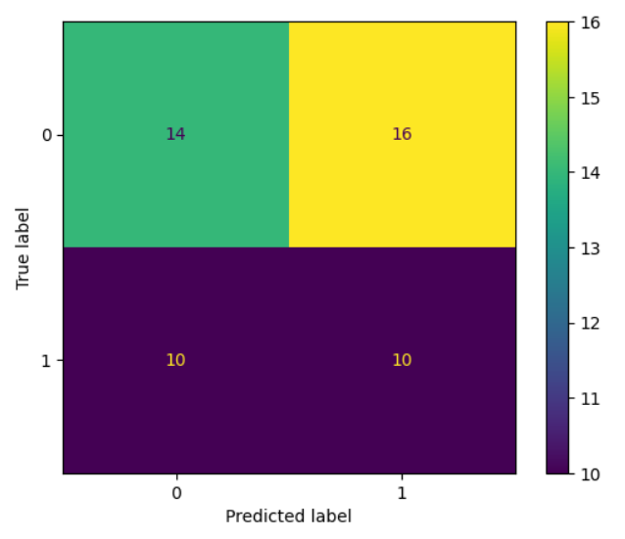

Figure 11. Tucker with autoencoder and one-class SVM confusion matrix

# Results Summary

## Performance of CP Decomposition Methods

* One-Class SVM: The best accuracy achieved was 44% with a CP decomposition rank of 80.
* Autoencoder-Neural Network: The best accuracy achieved was 46% with a CP decomposition rank of 85.
* Random Forest: The best accuracy achieved was 38% with a CP decomposition rank of 10.
* Autoencoder with One-Class SVM: The best accuracy achieved was 56% with a CP decomposition rank of 35.

The CP decomposition methods showed varying degrees of success in detecting anomalies. The combined Autoencoder with One-Class SVM approach achieved the highest accuracy among the CP decomposition methods, highlighting the potential benefit of integrating neural networks with traditional machine learning techniques.

## Performance of Tucker Decomposition Methods

Tucker decomposition was applied to the image datasets, and the same set of machine learning models as was done for CP decomposition were evaluated. The results are as follows:

* One-Class SVM: The best accuracy achieved was 56% with a Tucker decomposition rank of (65, 35, 65).
* Autoencoder-Neural Network: The best accuracy achieved was 58% with a Tucker decomposition rank of (95, 65, 65).
* Random Forest: The best accuracy achieved was 46% with a Tucker decomposition rank of (5, 65, 5).
* Autoencoder with One-Class SVM: The best accuracy achieved was 48% with a Tucker decomposition rank of (65, 35, 5).

The Tucker decomposition methods outperformed the CP decomposition methods on three out of four models. Notably, the Autoencoder-Neural Network model achieved the highest overall accuracy of 58% when combined with Tucker decomposition, indicating a significant improvement over the other methods.

## Comparative Analysis and Insights

Comparing the performance of CP and Tucker decomposition methods, several key insights were identified:

Variability of performance:

It was observed that multiple runs yield varying accuracy for each model. This variability is attributed to hardware limitations and timeouts when ran on a mid-performance laptop. However, even with these differences, the comparative performance between models are similar between runs.

The following are the results of three runs.

|  |  |  |  |
| --- | --- | --- | --- |
| **Model** | **Run #1 accuracy** | **Run #2 accuracy** | **Run #3 accuracy** |
| CP with one-class SVM | 0.54 | 0.54 | 0.44 |
| CP with autoencoder | 0.62 | 0.46 | 0.46 |
| CP with random forest | 0.44 | 0.44 | 0.38 |
| CP with autoencoder and one-class SVM | 0.62 | 0.46 | 0.56 |
| Tucker with one-class SVM | 0.68 | 0.48 | 0.56 |
| Tucker with autoencoder | 0.74 | 0.62 | 0.58 |
| Tucker with random forest | 0.50 | 0.50 | 0.46 |
| Tucker with autoencoder and one-class SVM | 0.62 | 0.46 | 0.48 |

This report uses the most conservative results or Run #3.

Overall Performance:

Tucker decomposition methods demonstrated superior performance in anomaly detection compared to CP decomposition methods. The higher accuracy rates suggest that Tucker decomposition is more effective in preserving essential features for anomaly detection in high-dimensional image data. This enhanced performance is due to the higher dimensional representation of Tucker decomposition compared to CP decomposition.

Best Performing Model:

The Autoencoder-Neural Network model combined with Tucker decomposition achieved the highest accuracy of 58%, making it the best-performing model in this study. This model outperformed the second-best method, Tucker with One-Class SVM, by 2%.

Optimal Decomposition Ranks:

The optimal Tucker decomposition rank for the highest accuracy was identified as (95, 65, 65), while the optimal CP decomposition rank is 35 for Autoencoder with One-Class SVM model.

# Recommendations

Future work should explore additional decomposition ranks, alternative neural network architectures, and hybrid approaches to further improve the performance of anomaly detection models. Additionally, applying these methodologies to different datasets and domains will help validate the generalizability and robustness of the findings.

# Project Goals

The project goals were achieved by successfully decomposing image sets using CP and Tucker decomposition methods, allowing the images to be treated as 2-dimensional signals. These signals were then processed through machine learning models to detect anomalies.

# Conclusion

This study demonstrates the potential of high-dimensional tensor decomposition methods, particularly Tucker decomposition, in improving anomaly detection in image datasets and signals. The superior performance of the Tucker decomposition combined with Autoencoder-Neural Networks underscores the importance of selecting appropriate preprocessing techniques and machine learning models for achieving high accuracy. The insights gained from this research provide a foundation for further advancements in anomaly detection and its applications across various domains.

# References

Kerner, H. R., Wagstaff, K. L., Bue, B. D., Wellington, D. F., Jacob, S., Horton, P., Bell III, J. F., Kwan, C., & Ben Amor, H. (2020). Comparison of novelty detection methods for multispectral images in rover-based planetary exploration missions. Data Mining and Knowledge Discovery, 34(6), 1642–1675

Manpreet Singh Minhas, John Zelek (2021). Anomaly Detection in Images. Journal of Computer Vision and Image Understanding, 208, 103235. doi:10.1016/j.cvi1.1

Beggel, L., Pfeiffer, M., Bischl, B. (2020). Robust Anomaly Detection in Images Using Adversarial Autoencoders. In: Brefeld, U., Fromont, E., Hotho, A., Knobbe, A., Maathuis, M., Robardet, C. (eds) Machine Learning and Knowledge Discovery in Databases. ECML PKDD 2019. Lecture Notes in Computer Science(), vol 11906. Springer, Cham. https://doi.org/10.1007/978-3-030-46150-8_13

This study partially uses AI tools such as OpenAI ChatGPT for grammatical corrections. All sections, codes, experiments and results were manually coded. For a copy of the codes or datasets, please request them from the contact information provided below.

# Contact Information

email: anthonycchan@gmail.com